

Practices for Secure Software Report

Table of Contents
Document Revision History 3
Client 3
Instructions 3
Developer 4
1. Algorithm Cipher 4
2. Certificate Generation 4
3. Deploy Cipher 4
4. Secure Communications 4
5. Secondary Testing 4
6. Functional Testing 4
7. Summary 4
8. Industry Standard Best Practices 4

Document Revision History

Version | Date | Author | Comments
1.0 | 4/19/2026 | Brandon Hazelton

Client



Instructions

Submit this completed practices for secure software report. Replace the bracketed text with the relevant information. You must document your process for writing secure communications and refactoring code that complies with software security testing protocols.

- Respond to the steps outlined below and include your findings.
- Respond using your own words. You may also choose to include images or supporting materials. If you include them, make certain to insert them in all the relevant locations in the document.
- Refer to the Project Two Guidelines and Rubric for more detailed instructions about each section of the template.

Developer
Brandon Hazelton

Algorithm Cipher

I used the SHA-256 cryptographic hash algorithm to secure data transmission. SHA-256 is part of the SHA-2 family and produces a 256-bit hash value. It is widely used due to its resistance to collisions and strong security. The algorithm uses one-way hashing, meaning the original data cannot be reconstructed from the hash. This ensures data integrity during transmission. SHA-256 does not rely on symmetric or asymmetric keys but instead uses deterministic hashing combined with secure random input values when needed.

Certificate Generation
Insert a screenshot below of the CER file.

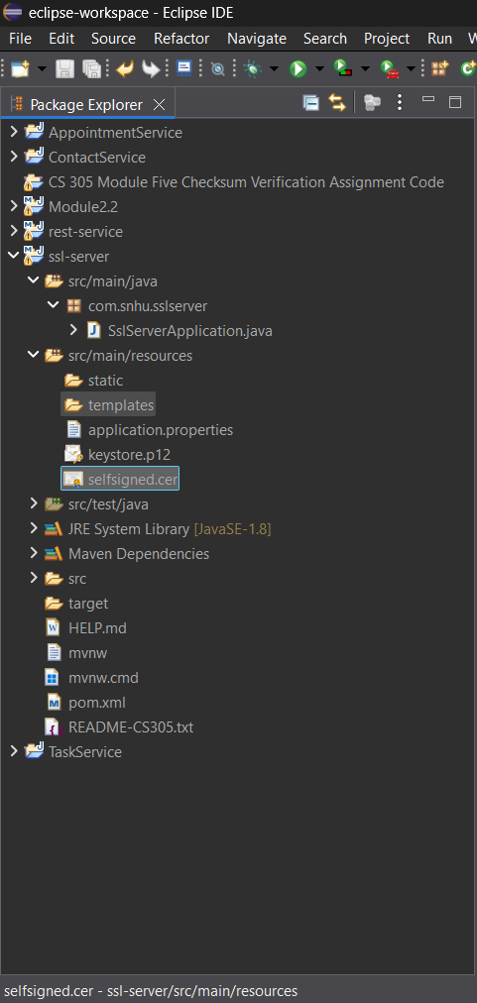

Deploy Cipher
Insert a screenshot below of the checksum verification.

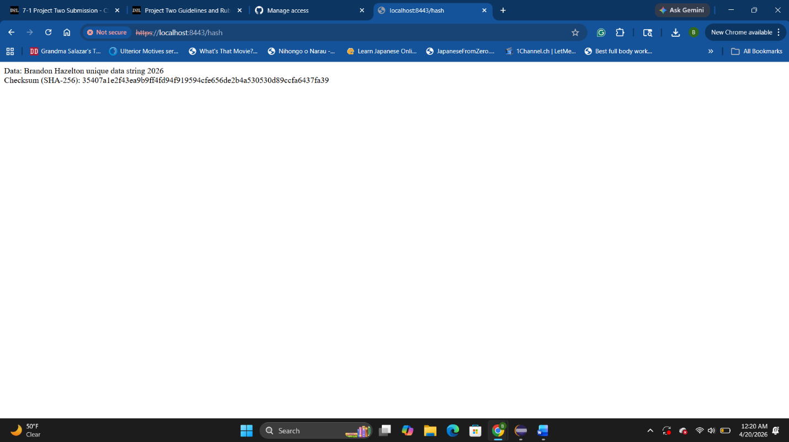

Secure Communications
Insert a screenshot below of the web browser that shows a secure webpage.



Secondary Testing
Insert screenshots below of the refactored code executed without errors and the dependency-check report.
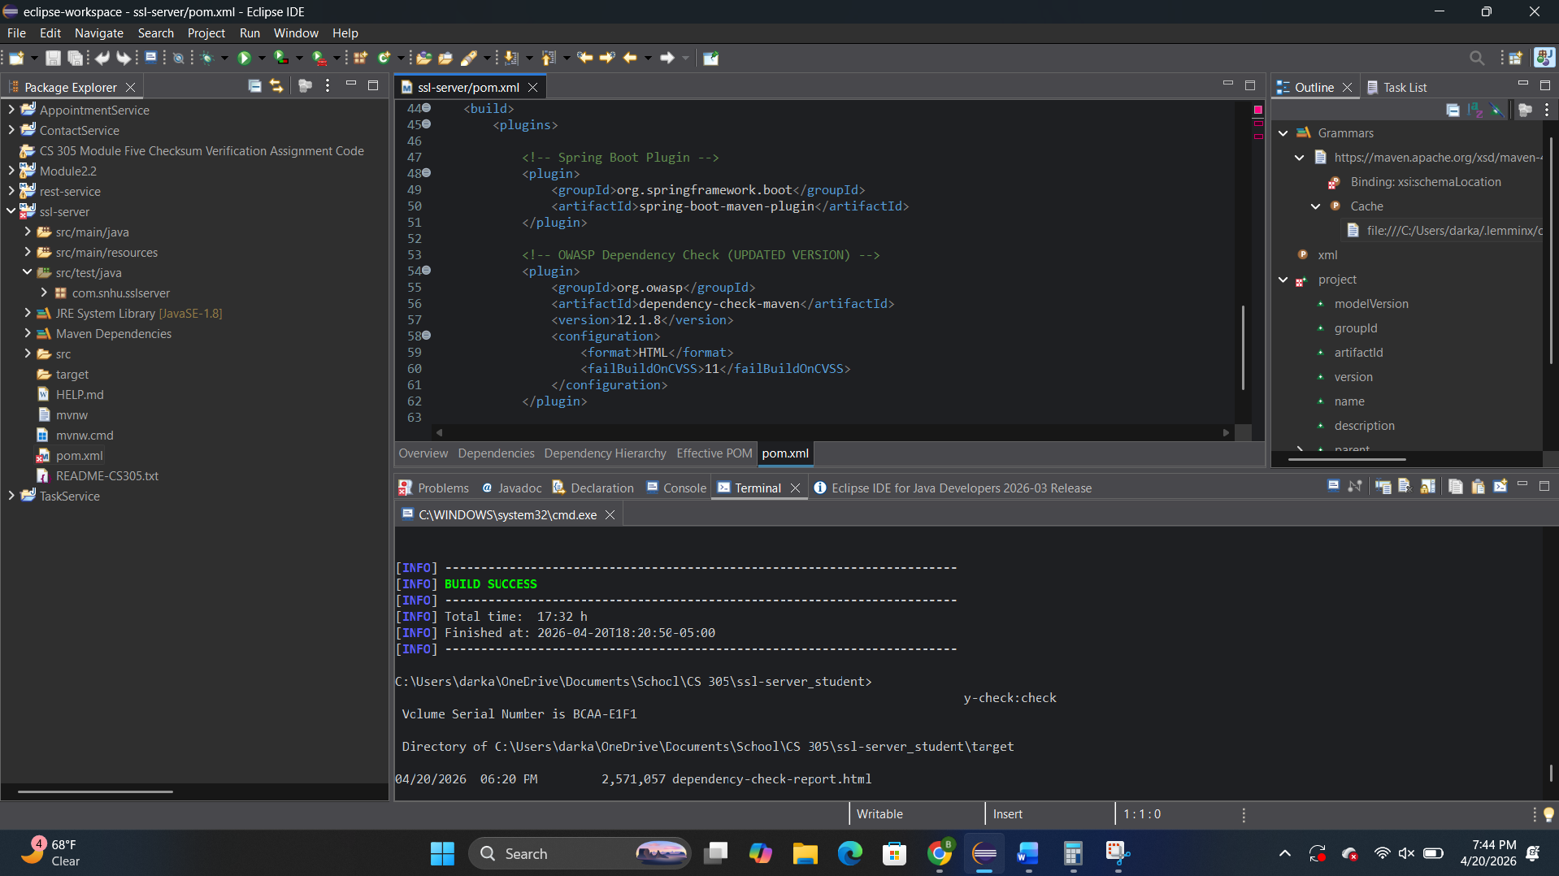
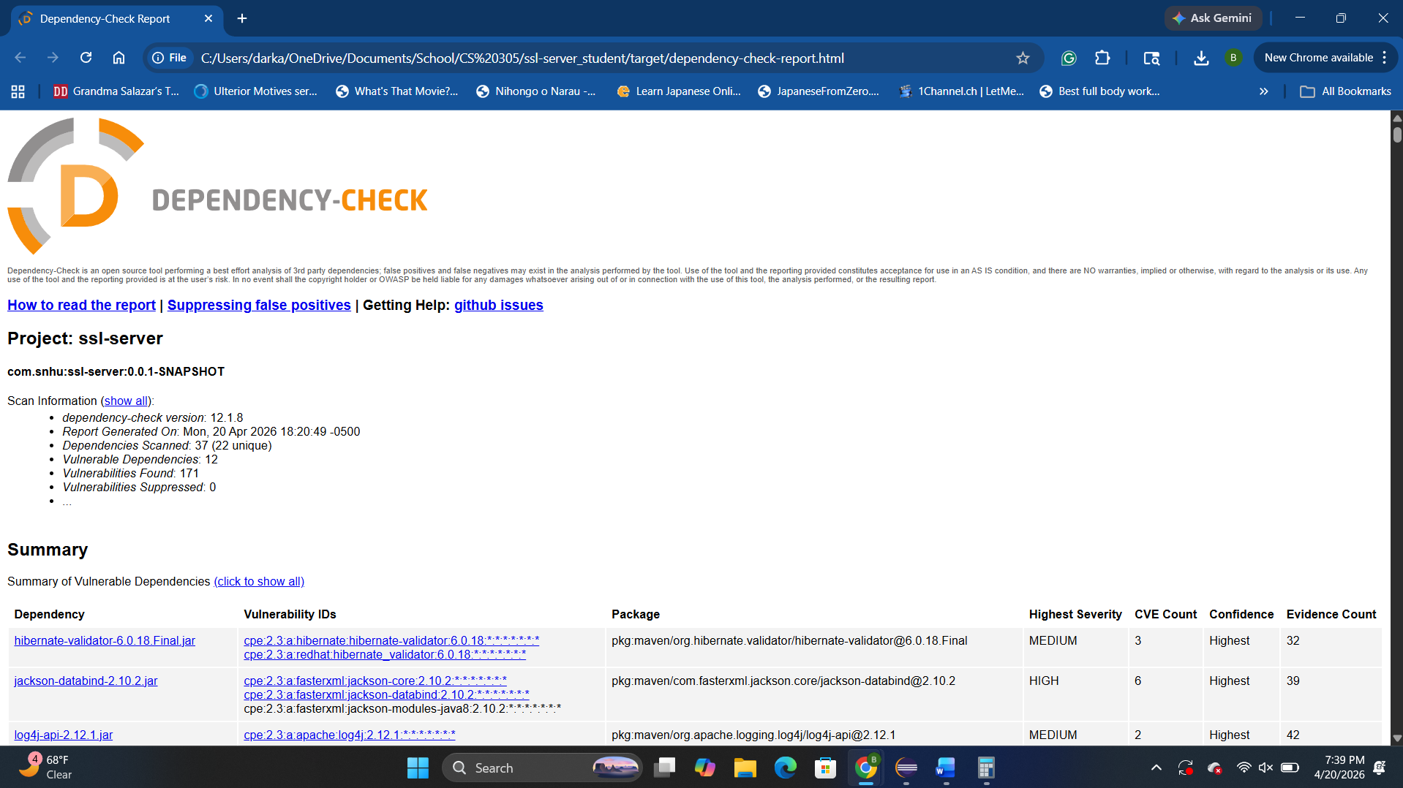

Functional Testing
Insert a screenshot below of the refactored code executed without errors.

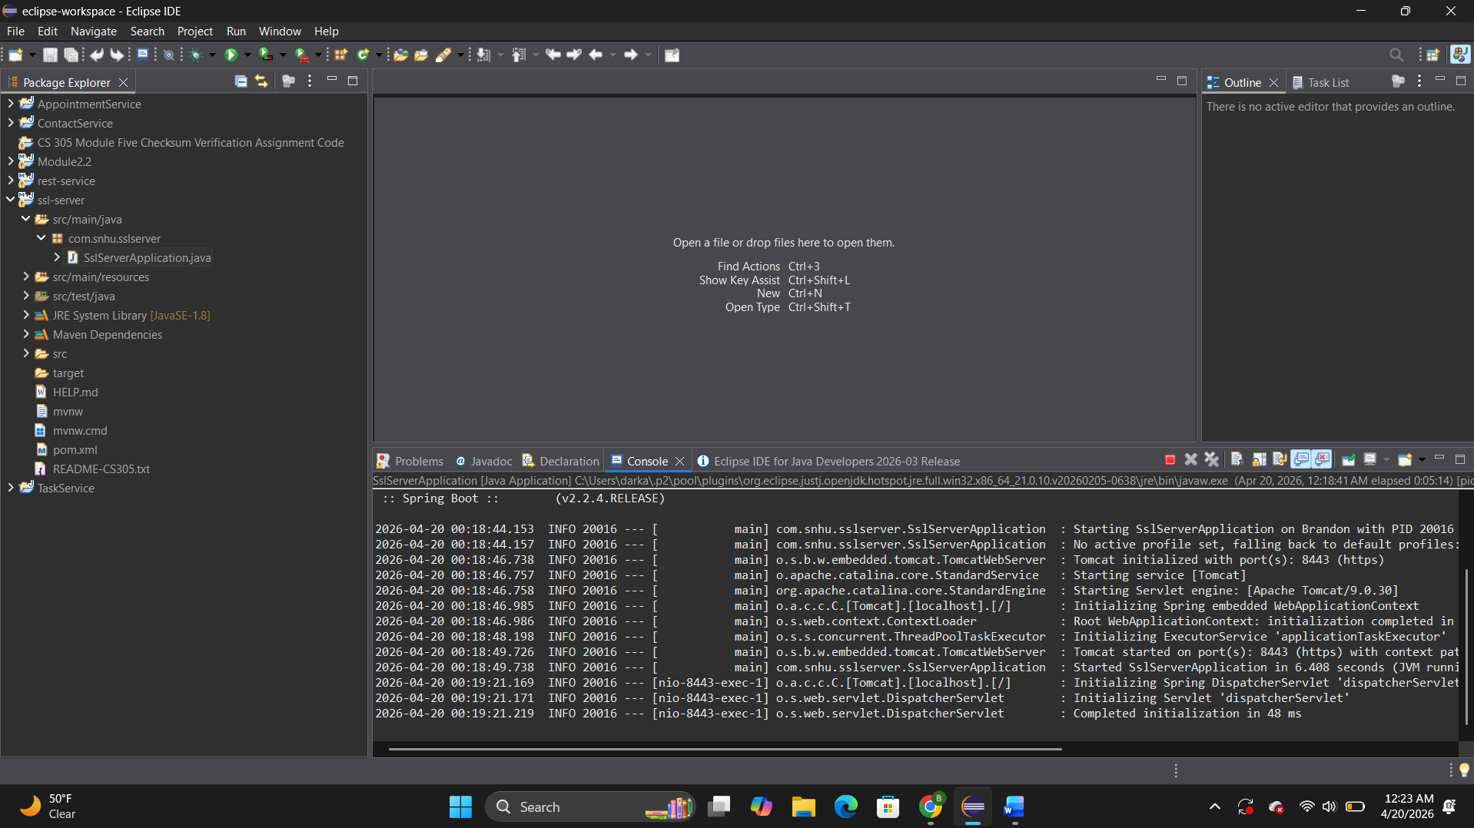

Summary

The application was refactored to improve security and ensure compliance with software security testing protocols. Several layers of security were added, including the implementation of HTTPS using a self-signed certificate, which ensures encrypted communication between the client and server. This protects sensitive data during transmission and prevents unauthorized access.

A SHA-256 cryptographic hash function was integrated into the application to provide checksum verification. This allows the system to validate data integrity by generating a unique hash for input data, ensuring that information has not been altered during transmission. The use of SHA-256 provides a strong, one-way hashing mechanism that enhances data protection.

In addition to implementing encryption and hashing, the application was tested using both functional and static testing methods. Functional testing confirmed that the application runs without errors and that all features operate as expected. Static testing using OWASP Dependency-Check identified vulnerabilities within third-party dependencies, but no new vulnerabilities were introduced by the refactored code.

The security improvements align with the vulnerability assessment process by addressing key areas such as secure communication, data integrity, and dependency risk awareness. By applying multiple layers of security, including encryption, certificate management, and vulnerability scanning, the application demonstrates a strong defense-in-depth approach. Overall, the refactored application meets the required security standards and provides a more secure environment for handling sensitive financial data.

Industry Standard Best Practices

Industry standard best practices for secure coding were applied throughout the refactoring process to maintain and improve the application’s overall security. One key practice was the implementation of HTTPS, which encrypts data transmitted between the client and server. By configuring a self-signed certificate, the application ensures that sensitive information is protected from interception and unauthorized access during communication.
Another best practice applied was the use of the SHA-256 cryptographic hash algorithm for checksum verification. SHA-256 is widely recognized as a secure hashing standard and is used to ensure data integrity by producing a unique, one-way hash value. This prevents data tampering and supports secure validation of transmitted information.
In addition, static analysis using the OWASP Dependency-Check tool was performed to identify known vulnerabilities in third-party libraries. This reflects an industry best practice of continuously monitoring dependencies for security risks and keeping software components up to date. Although some vulnerabilities were identified within external libraries, no new vulnerabilities were introduced by the refactored code.
Secure coding principles such as proper configuration management, minimizing attack surfaces, and validating input were also followed to maintain the application’s existing security. These practices help prevent common vulnerabilities such as injection attacks and misconfigurations.
Applying these industry standard best practices is essential to the company’s overall well-being because it helps protect sensitive financial data, reduces the risk of security breaches, and ensures compliance with modern security expectations. By incorporating multiple layers of protection and continuously evaluating potential risks, the application provides a more secure and reliable environment for both the organization and its users.

